**Task 1 IN GOOGLE CLOUD**

**CLOUD CONSOLE Setup Instructions**

**Step 1: Set Up Google Cloud Project**

1. **Go to Google Cloud Console**: Google Cloud Console
2. Sign up for an account

**Step 2: Create a Cloud Storage Bucket**

1. **Open Cloud Storage**:
   * Click **"Create Bucket"**.
2. **Configure the Bucket**:
   * **Bucket Name**: Enter a globally unique name (e.g., my-storage-bucket-123).
   * **Region/Location**: Choose a location (Multi-region, Dual-region, or Region).
   * **Storage Class**: Choose between **Standard, Near line, Cold line, or Archive**.
   * **Access Control**:
     + Choose **Uniform** (recommended) for simple IAM-based control.
3. **Finalize & Create**:
   * Click **Create** to provision storage bucket.

**Step 3: Upload & Manage Files**

* **Upload a File**:
  + Open bucket and click **"Upload Files"**.
* **Create a Folder**:
  + Click **"Create Folder"** to organize your files.

**Step 4: Set Permissions & Access Control**

1. **IAM Permissions**:
   * Go to **Cloud Storage > Bucket > Permissions**.
   * Click **"Add"** to grant roles like:
     + **Storage Admin** (full control)
     + **Storage Object Viewer** (read-only)
     + **Storage Object Creator** (upload only)
2. **Make Public (Optional)**:
   * Click on an object.
   * Click **"Edit Permissions"** and add **"allUsers"** with **"Reader"** role.

**Step 5: Access Files via Public URL**

* The public URL format:

arduino

CopyEdit

https://storage.googleapis.com/[BUCKET_NAME]/[OBJECT_NAME]

**Created Bucket codetech**

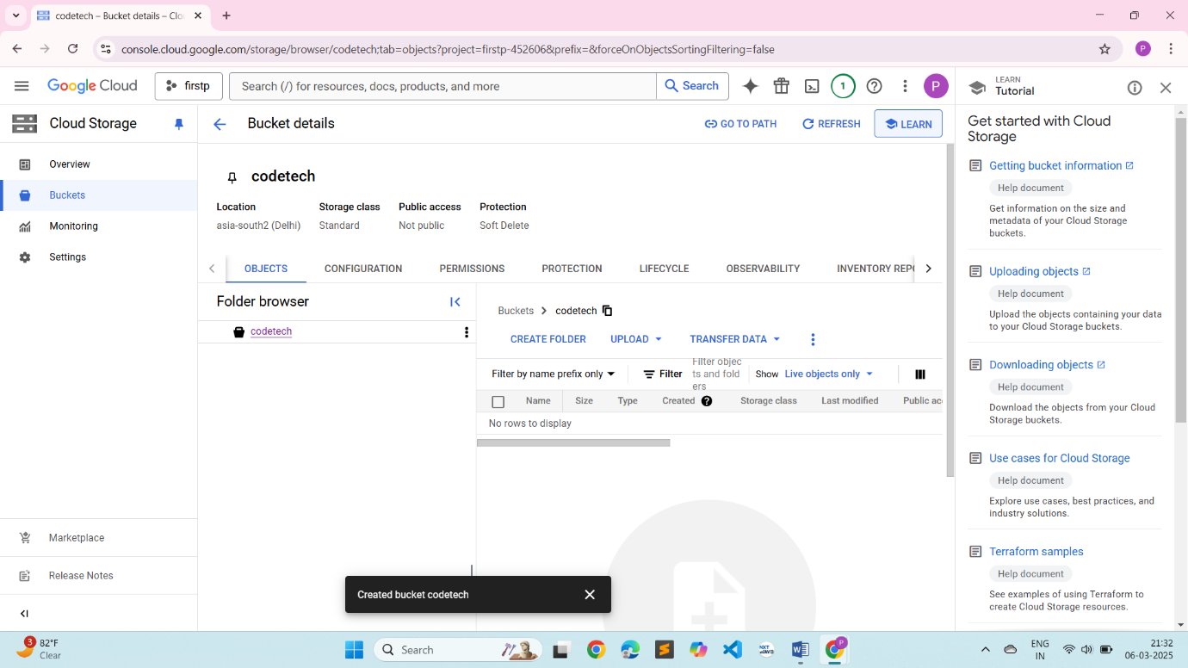

**Uploaded file**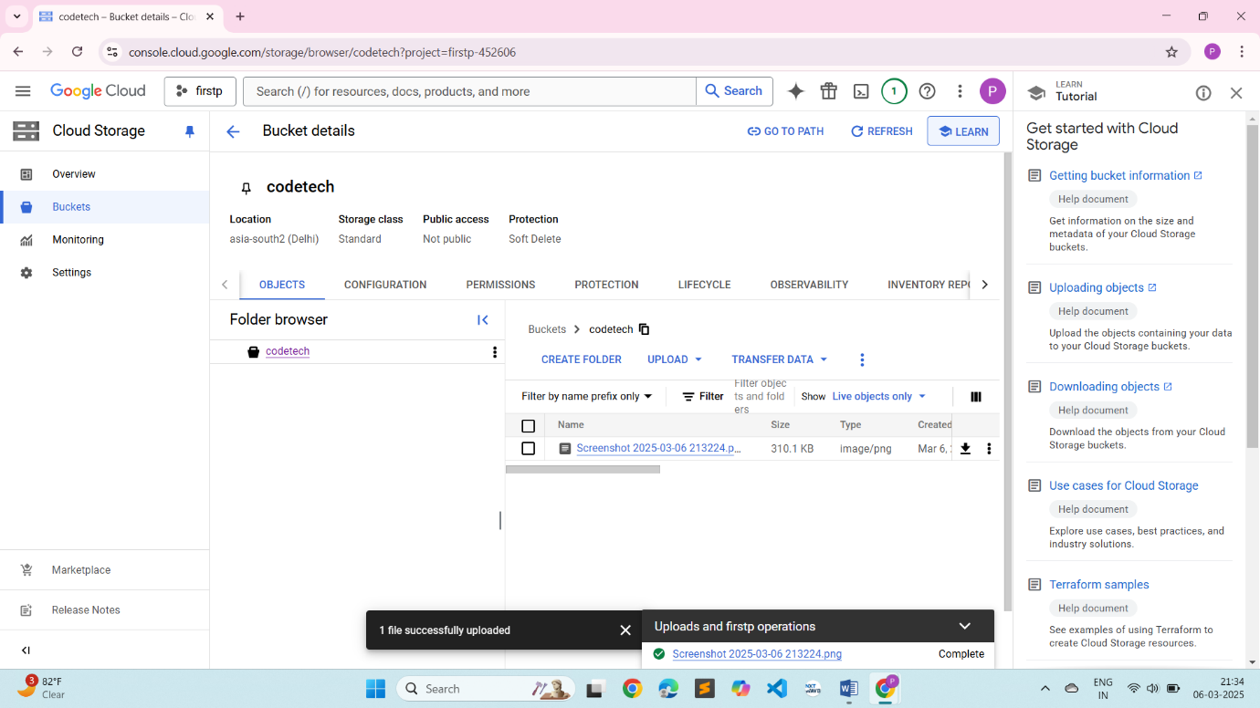

**Access Control Configure**

